Saturday French Program at La Petite École 2025

La

Petite

École

REGISTRATION INFORMATION 2025

Child’s Name:

_________________________________________________________

Gender:

Boy

Girl

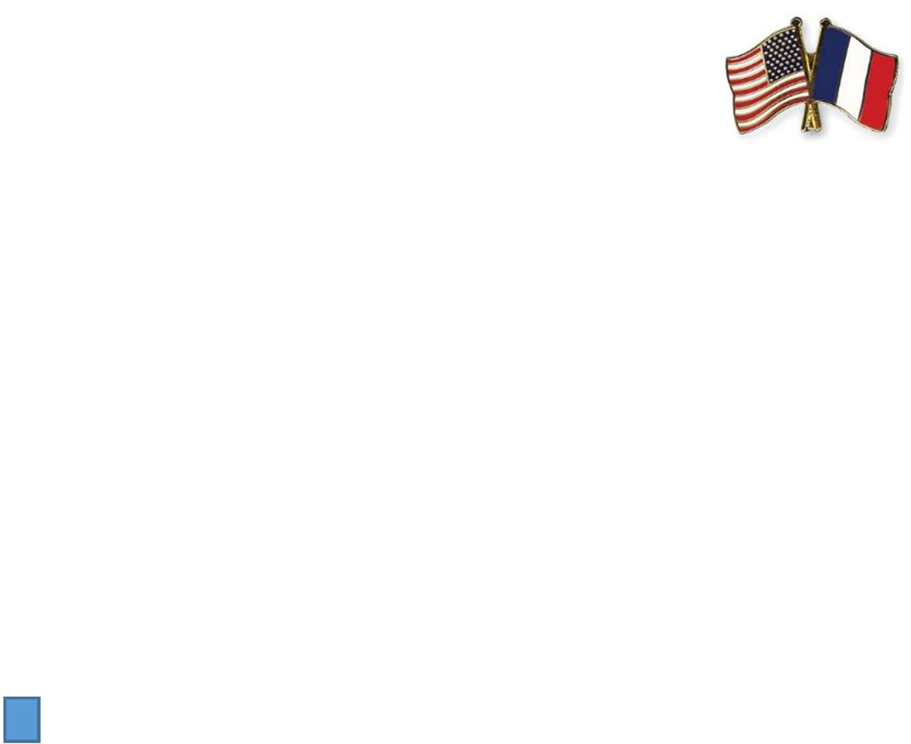

Street Address: ____________________________________________

Date of Birth: ______________

City, State, Zip: ____________________________________________

Phone: ___________________

Email: ____________________________________________________

Parent/Guardian Name (and address if

different):______________________________________________

Parent/Guardian Name (and address if different):______________________________________________

How did you learn about La Petite École?

____________________________________________

Does your child have any needs for which she or he may need to receive special services during school? Yes ________ No __________ If yes, please describe:

**Saturday French Program at La Petite École**

This program is designed for our graduates and is also open to new students!  
Due to high demand from our graduates’ families, we are excited to announce a new French learning program.

🗓 **Session Dates:**  
October 18 • October 25 • November 1 • November 8 • December 6 • December 13

🕘 **Time:** 9:15 AM – 10:30 AM  
📍 **Location:** La Petite École – St. Paul’s Church  
28 Lincoln Avenue, Pittsford, NY 14534

💰 **Cost:** $250  
👧🧒 **Ages:** 5–10 years old  
⚠️ **Spots are limited!**

This fun and engaging program is designed to help children continue (or begin!) their French learning journey through songs, games, stories, and interactive activities.

📩 **To Enroll:**  
Please fill out the **attached registration form** and send a **check for $250** payable to *La Petite École*.  
You may also visit **lapetiteecolekm.com** and contact us through the **Contact** page if you have any questions.  
We will confirm your child’s enrollment upon receipt of payment and the completed form.